The Evolution of Vernalisation in Flowering Plants

In flowering plants, sensing surrounding environmental conditions and regulating flowering time to tightly correspond with the changing environment is the key to maximising reproduction potential. Flowering too early can result in damage to delicate reproductive organs during unseasonal cold ‘snaps’, while flowering too late could result in the plant missing out on favourable spring time growing conditions. Crop planting schedules are planned to specifically exploit a plant’s mechanisms to respond to environmental cues, such as vernalisation, to maximise yield. While individual plant species respond differently at the genetic level to their changing environment, the predominant mechanism used by plants is to regulate their time to transition from vegetative to reproductive growth.

The Vernalisation Response

Vernalisation is characterised by a prolonged (a period of greater than ten days) exposure to low, but non-freezing temperatures. Vernalisation (from the Latin *vernum*, meaning *spring*), and its effect on harvest time and crop yield has been a central plant biology research focus for over 150 years (Klippart 1857; Gassner 1918). The temperature at which the vernalisation response is triggered differs widely between individual crop species, and even between cultivars of the same species (see Table 1). It is theorised that the threshold temperature that triggers a vernalisation response can be calculated by examining the rate of growth under a range of temperatures, extrapolating the curve, then selecting a temperature a few degrees above the inferred basal temperature (Angus et al. 1980). Sugar beet (*Beta vulgaris*), and carrot (*Daucus carota*), must be exposed to vernalisation before the plant is able to transition to flowering (an *absolute* vernalisation response) (Dijk et al. 1997; Alessandro et al. 2013). However, in wild populations, plants grown in warmer temperatures require a shorter period of vernalisation to trigger flowering. In species where vernalisation is not an essential requirement for flowering transition (a *facultative* vernalisation response), such as in *Arabisopsis* *thaliana* (*Arabidopsis*) (Burn et al. 1993; Bastow et al. 2004), narrow leaf lupin (*Lupinus Augustifolius*) (Landers 1995), and winter wheat (*Triticum aestivum*) and barley (*Hordeum vulgare*) (Trevaskis et al. 2006; Oliver et al. 2009), vernalised plants flower sooner than plants that have not been exposed to a vernalisation treatment (Sheldon et al. 2000). The genetic pathways for the vernalisation response in plants are family-specific: not just between dicotyledonous (dicots) and monocotyledonous (monocots) species, but also within different dicots (Reeves et al. 2007). Despite these differences, the gene pathways in vernalisation responsive plant species are epigenetic in nature, for example; a vernalisation sensitive plant will express a distinct phenotype when vernalisation, however these. epigenetic-based phenotypic differences are reset in the following generation(s).

In *Arabidopsis* and other dicots, the shoot tip is; i) located at the crown of the plant; ii) contains the shoot apical meristem (SAM), and; iii) is composed of a collection of pluripotent stem cells that slowly divide and differentiate into the various progenitor cells necessary for vegetative tissue growth (Meyerowitz 1997; Fletcher 2002). In *Poa pratensis* (Kentucky Bluegrass) and other monocots, the pluripotent stem cells location differs with this cell population present in the basal meristem at the bottom of the plant, just above the soil line (Etter 1951). Regardless of location, after floral induction, the types of progenitor cell that the pluripotent meristem cells produce changes from those required for vegetative development to progeny cells necessary for the generation of tissues and organs essential for for flowering. In 1962, Wellensiek showed that in a number of plants with a SAM, moving vernalised shoot stock to non-vernalised root stock resulted in the generation of a plant expressing a vernalised phenotype (Wellensiek 1962). Similarly, moving non-vernalised shoot stock to vernalised root stock resulted in the production of plants expressing a non-vernalised phenotype. Together, Wellensiek’s early observations indicated that while some plant tissues and/or organs were vernalisation responsive, the most crucial location for a phenotypic response to vernalisation was the shoot tip, a structure that contains the SAM in the studied dicot species. Presumably, a similar effect would be seen in monocots, where grafting a basal meristem of a vernalised plant onto a non-vernalised root stock would result in the expression of a vernalisation, and vice versa. However, the literature is not clear in this regard.

Vernalisation in *Arabidopsis* *thaliana*

In *Arabidopsis*, the MADS-box (MCM1, AGAMOUS, DEFICIENS, and SRF, serum response factor) transcription factor, FLOWERING LOCUS C (FLC) is the key mediator in the transition from vegetative to reproductive phase change (Riechmann & Meyerowitz 1997). Prior to vernalisation, *FLC* expression is promoted by FRIGIDA (FRI), FRIGIDA-LIKE1(FRL1) and FRIGIDA-LIKE2 (FRL2; Werner et al. 2005). *FLC* acts as a transcription repressor, specifically repressing the expression of FLOWERING LOCUS T (FT; Sheldon et al. 2000). In the *Arabidopsis* ecotype *Col*-0, when *FLC* is expressed, VERNALISATION 2 (VRN2) complexes with CURLY LEAF (CLF), SWINGER (SWN) and FERTILIZATION-INDEPENDENT ENDOSPERM (FIE) to form the VERNALISATION 2 (VRN2)/Plant Homeo domain Polycomb Repression Complex 2 (PHD-PRC2; Köhler & Villar 2008), and this complex constitutively binds the *FLC* locus to maintain FLC in an open confirmation. This is primarily achieved via H3 acetylation, loosening the nucleosome-FLC interaction and thus allowing access to the transcriptional machinery to promote *FLC* expression (De Lucia et al. 2008).

When *Arabidopsis* Col-0 is exposed to non-freezing cold, *VERNALISATION INSENSITIVE 3* (*VIN3*), *VERNALISATION 5/VIN3-LIKE* (*VEL1*) and *VERNALISATION 5* (*VRN5*) expression is triggered. VIN3, VEL1 and VRN5 bind to the VRN2/PHD-PCR2 complex to promote histone H3 deacetylation, and *VRN2*-directed trimethylation of H3K9 and H3K27 of the *FLC* locus (Sung & Amasino 2004). Furthermore, the FLC promoter region is simultaneously demethylated at H3K4 (Finnegan et al. 2005). Together, these chromatin modifications, closes the open conformation of the *FLC* locus, blocking transcriptional machinery from accessing *FLC*, thereby repressing *FLC* expression (Finnegan & Dennis 2007). This epigenetic-based repression of *FLC* is stable and irreversible, ensuring that the transition of vernalised Col-0 from vegetative to reproductive development is permanent (Levy et al. 2002).

When the *FLC* locus adopts transcriptionally inactive confirmation, the expression of FT, *FLOWERING TIME* (*FT*), the FT homolog *TWIN SISTER OF FT* (*TSF*), and *SUPPRESSOR OF OVEREXPRESSION OF CONSTANS 1* (*SOC1*) is promoted. The FT protein travels through the phloem to the SAM (Corbesier et al. 2007). In the SAM, FT triggers floral induction by promoting the transition of meristem cells to a reproductive fate via promoting the expression of *LEAFY* (*LFY*) and *APETALA1* (*AP1*), two primary promoters of floral apical meristem development (Amasino 2004). Together, LFY and AP1 promote the pluripotent cells of the SAM to differentiate and divide into reproductive tissues, and this eventually leads to the formation of flowering bodies (Ref).

There are five additional FLC homologs encoded by *Arabidopsis*, and all five are alsoregulated by vernalisation. Like FLC, the expression of *MADS AFFECTING FLOWERING1* (*MAF1*)through to *MAF4* are all downregulated by vernalisation. However, the expression of *MAF5* is upregulated by vernalisation (Ratcliffe et al. 2003). Furthermore, it has been demonstrated that different isoforms of the *MAF2* transcript are expressed at different temperatures, with *maf2* mutants althoughin *Arabidopsis*, -directed regulationFLCis of vernalisation-induced flowering in Arabidopsisthat the of FLC are also important contributors to the regulation of flowering in Arabidopsis.further indicating thatis a promoter of FLC *vin3* have lost the with vin3 plants failing to respond

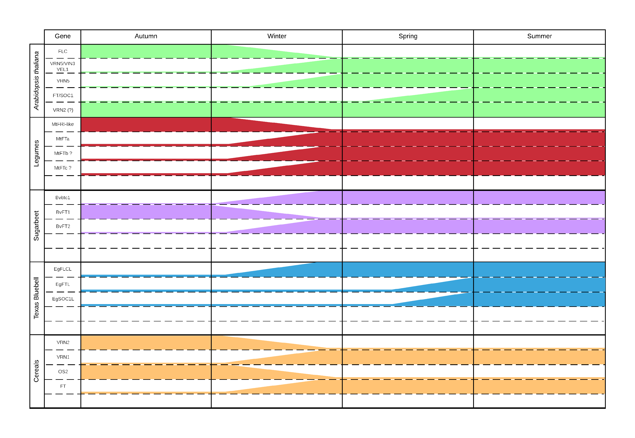

Figure 1 – Summary of genes expressed in several plant species after exposure to vernalisation conditions.

Vernalisation Response in Legumes

There are multiple members of the *Fabaceae* (legume) genera that respond to vernalisation. *Medicago truncatula* encodes three *FT* gene classes, including *FTa*, *FTb* and *FTc.*  These three FT gene classes are conserved across the *Fabaceae*, but curiously to date, have not been reported in any other angiosperm (Hecht et al. 2011). *Medicago* encodes five *FT-like* genes , including *MtFTa1*, *MtFTa2*, *MtFTb1*, *MtFTb2* and *MtFTc* (Laurie et al. 2011), and of these, *MtFTa1* is over-expressed in the *Medicago* spring mutant (Putterill et al. 2013). In wild-type *Medicago* however, *MtFTa1* overexpression is only observed after exposure to vernalisation (Jaudal et al. 2013). *Medicago* species also appear to lack an orthologs of *Arabidopsis* FLC and MAF (Hecht et al. 2005), but do encode for a FRI-like (*Mt*FRI-like) protein. When the *MtFRI-like* coding sequence was expressed in *Arabidopsis* Col-0, flowering time was delayed. This strongly suggests that *Mt*FRI-like plays a similar functional role to *At*FRI: the promotion of *FLC* expression (Chao et al. 2013).

In addition to Medicago, the vernalisation response of pea (*Pisum*) has been studied (Reid & Murfet 1975). More recently, research in the *Lupinus* genus, (namely *L. albus*, *L. augustifolius* and *L. luteus*) has revealed a vernalisation response similar to that of *Arabidopsis* (Gladstones & Hill 1969; Landers 1995). In both *Pisum* and *Lupinus*, , decreased time to flowering is inversely proportional to the time that seedlings are vernalised. While the exact mechanisms for this phenotypic response has not been determined at the molecular level in these genera, it could be surmised that homologs of the *MtFT* family would also be mediating a similar, and central role.

Even in the absence of MADS-box orthologs to FLC, and to MAF1through to MAF5, proteins critical to the vernalisation response and flowering time in *Arabidopsis*, *Fabaceae* are still able to response to vernalisation environmental cues, as evidenced by the over-expression of *MtFTa1* in the *Medicago* spring mutant plant line and the homologous functional role mediated by *MtFRI-like* when expressed in *Arabidopsis*. However, the exact mechanistic role directed by of these vernalisation response regulators in legumes remains to be determined.

Vernalisation in Texas Bluebell

Texas Bluebell (*Eustoma* spp.) is an ornamental flowering plant native to the southern United States, Central America and the northern regions of South America. *Eustoma* have a similar vernalisation response to *Arabidopsis* and *L. augustifolius*, where the time to flowering is inversely proportional to the period of cold exposure (Pergola 1992). *Eustoma* *grandiflorum* encodes homologs to *Arabidopsis* FLC, FT and SOC1 (EgFLCL, EgFTL and EgSOC1L respectively). EgFTL and EgSOC1L appear to be functional homologs of their *Arabidopsis* counterparts and are lowly expressed until restoration of an inductive photoperiod post vernalisation. At this time, the expression of *EgFTL* and *EgSOC1L* increases. However, *EgFLCL* appears to be lowly expressed during vegetative growth and only increases with the onset of vernalisation, the opposite expression profile to that widely reported for *Arabidopsis* *FLC* (Nakano et al. 2011). Alternatively, this may indicate that EgFLCL is more closely functionally related to *Arabidopsis* MAF5 than the other MADS-box proteins involved in vernalisation response, such as FLC and MAF2-5 (Ratcliffe et al. 2003). Therefore, rather than directly repressing the expression of *EgFTL*, EgFLCL may restrict the expression of a target gene which is itself a repressor of *EgFTL* expression in *Eustoma*.

Vernalisation in Sugar beet

Sugar Beet (*Beta vulgaris* ssp. *Vulgaris*) is extensively cultivated worldwide for its large, sucrose rich root organ. Photothermal induction (that is, exposure to vernalisation conditions followed by increased day length) is necessary for flowering in sugar beet (Owen et al. 1940). Because of an absolute vernalisation requirement for flowering, breeders have selected phenotypes that maintain the vegetative and root growth state in order to maximise root yield. Recent studies have characterised the molecular mechanisms underpinning the vernalisation response in beet to demonstrate that they are distinct to those of other species (Pin et al. 2012). Two paralogous *Flowering Locus T* (*FT*)genes, *BvFT1* and *BvFT2*, central to the regulation of flowering, are controlled by BOLTING TIME CONTROL1 (*Bv*BTC1; the *B*. *vulgaris* ortholog of *At*FLC), and inturn *Bv*FT1 is responsible for regulating *BvFT2* expression(Pin et al. 2010). The requirement for two FT-like genes for control of flowering time in *B*. *vulgaris* is distinct to the requirement of a single FT to control flowering in *Arabidopsis*. In biannual wild type sugar beet, ecotypes that naturally occur further north contain a greater composition of a recessive allele of *Bvbtc1*, display an absolute vernalisation requirement phenotype. As the latitude increases and the location becomes closer to the warmer climate of the Mediterranean, the requirement for vernalisation for the promotion of flowering diminishes, and furthermore, the dominant *BvBTC1* allele predominates in the naturally occurring varieties of this region (Dijk et al. 1997). While the vernalisation pathway in *B. vulgaris* is distinct from *Arabidopsis*, it also containsa number of homologous pathways, including the photoperiod pathway (Chia et al. 2008), and the autonomous pathway (Abou-Elwafa et al. 2011). However, these pathways require further experimental characterisation.

Vernalisation in Cereals

Monocots, such as bread wheat (*Triticum aestivum*), barley (*Hordeum vulgare*) and *Brachypodium distachyon* (a model monocot) have a vernalisation pathway that is distinct to that of *Arabidopsis* and other dicot species. While there are a number of genetic mechanisms conserved between monocots and dicots, the most notable difference is the absence of a known *Arabidopsis* FLC homolog. Instead, the interplay between *VRN1* (a MADS-box transcription factor), *VRN2* (the cereal VRN2 is distinct from the *AtVRN2*; Yan et al. 2004), and *VRN3* (a homolog of *AtFT*; Trevaskis et al. 2007), regulates the response to vernalisation.

In cereals, VRN1 serves two purposes; i) a regulator of *VRN2* expression, and; ii) a key meristem identity gene (Trevaskis et al. 2007). Recessive alleles of *VRN1* in winter wheats (*vrn1-A1|B1|D1*) require vernalisation for expression induction; otherwise the winter wheat varieties express a late flowering phenotype. Spring wheat varieties express dominant *VRN1* alleles, and unsurprisingly are naturally early flowering (Trevaskis et al. 2003). During vernalisation of winter barley, H3K27 demethylation and H3K4me3 trimethylation occurs at the *HvVRN1* locus. This modifies the shape of the local chromatin to allow the chromatin to adopt an open conformational, allowing transcriptional machinery access to the *VRN1* template, and hence, promotion of *VRN1* expression (Oliver et al. 2009). Similar to the chromatin modifications at the *FLC* locus in *Arabidopsis*, this epigenetic change is stable. However in winter barley, and in direct contrast to AtFLC chromatin modifications, this conformational change permits, rather than restricts, transcriptional machinery access to the *HvVRN1* locus.

Similar to the *Arabidopsis* flowering pathway where FLC represses *FT* expression, HvVRN2represses the expression of *HvVRN3* (Ream et al. 2014). Prior to vernalisation of winter cereals, the floral repressor ODDSOC2 (OS2) is also present at high levels, and functions together with HvVRN2 to maintain the cereal in a vegetative growth state (Greenup et al. 2010). After vernalisation, increased HvVRN1 represses *HvVRN2* expression. Low HvVRN2 levels allows for the expression of *HvVRN3*, increasing HvVRN3 levels, which ultimately triggers the transition to flowering in winter barley (Trevaskis et al. 2006). High HvVRN1 levels post exposure to vernalisation also stably inhibits *OS2* expression. Reduced OS2 levels promotes the expression of *FPF1*, which in turn promotes the transition to a flowering state. This mechanism of VRN1 repressing *VRN2* expression is readily observed in spring cereals, as *VRN1* is expressed in these spring varieties regardless of their exposure (or there lack of) to vernalisation.

*VRN3* is the downstream target of VRN2. Following VRN1 repression of *VRN2* expression (that is; after vernalisation of winter cereals), decreased VRN2 allows for the expression of *VRN3*, the homolog of *Arabidopsis* *FT.* VRN3 subsequently interacts with VRN1, which in addition to acting as a repressor of VRN2 expression, VRN1 is also a promoter of meristem identity and developmental transition to flowering. It is only at this point that the cereal can transition from its state of vegetative development to a state of reproductive growth.

Taken together, the lack of an FLC homolog, in addition to the dual functionality of VRN1, both as a meristem identity factor and as a represser of *VRN2* expression, demonstrates a genetic divergence of the cereals from the dictot plants in regards to their response to vernalisation.

Vernalisation in the *Asteraceae*

While much of the historic research attention has focused on the vernalisation response of major crop species and the genetic model plant *Arabidopsis*, current research regarding the vernalisation response in safflower, and indeed, other members of the *Asteraceae* family (one of the largest and most diverse flowering plant families) is scarce. Early research in lettuce (*Lactuca sativa*) reported that germinated seed that had been vernalised prior to planting responded by progressing to the bolting stage up to four weeks earlier than unvernalised seed (Figure 2) (Gray 1942; Warne 1947; Rappapport et al. 1956). Later studies indicated that lettuce indeed responsed to vernalisation and extending day length cues. However, this research also showed that lettuce was still able to transition to flowering in the absence of these cues (Waycott 1995). Although this research was restricted to studying the physiological response of lettuce to vernalisation they strongly indicated a *facultative* vernalisation response in lettuce, similar to *Arabidopsis*

Chicory (*Cichorium intybus*) is an *Asteraceae* with an absolute vernalisation requirement. *CiFL1*, a MADS-box transcription factor with significant sequence homology to *Arabidopsis FLC*, is expressed during vegetative growth. Similar to the expression profile of AtFLC when *Arabidopsis* is exposed to vernalisation conditions, the expression of CiFL1 is repressed post vernalisation of chicory (Périlleux et al. 2013). Furthermore, when *CiFL1* was over-expressed in *Arabidopsis*, the resulting Arabidopsis transformant lines showed a significant . This strongly indicates functionality of CiFL1 and AtFLC in the Arabidopsis flowering chicory a areer again to reveal thatvernalisation-mediated repression of CiFL1 expression isand the repression of FLC expression vernalised

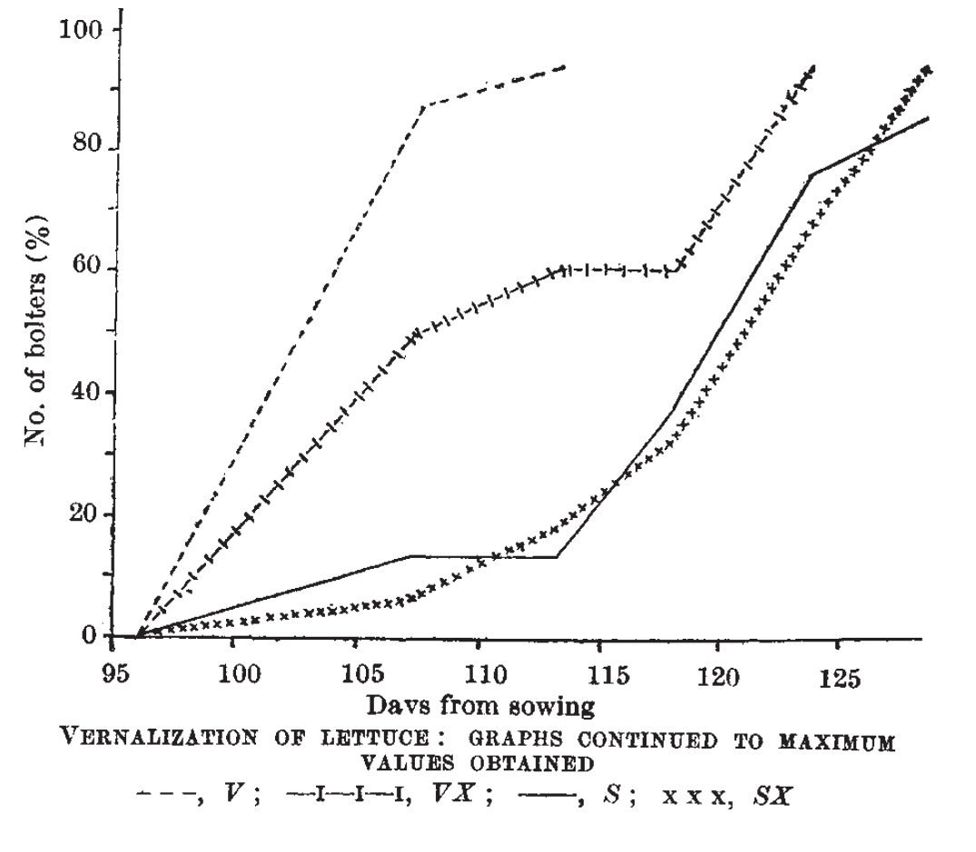

Figure 2 – The effect of vernalisation on days to bolting in lettuce, taken from (Warne 1947)

Early studies in safflower have revealed that in some varieties there is a relationship between photoperiod, vernalisation and a decrease in the time to flowering (Zimmerman 1973). While a FLC homolog may be present in many species (Reeves et al. 2007), based on what is seen in *Eustoma*, there may be no functional homolog of FLC in *Asteraceae*, with any homology to the well characterised Arabidopsis FLC purely being at the nucleotide level. Limited *Asteraceae* genetic resource availability makes the molecular characterisation of vernalisation within this genus challenging. As further resources become available, and are more thoroughly annotated, the molecular mechanisms by which vernalisation, as well as other factors, affect flowering time will become better understood.

Phylogenetic Analysis of Vernalisation Responsive Species

Approximately 34 million years ago, the geological transition from the tropical Eocene age to the modern, temperate Oligocene age occurred (Silva & Jenkins 1993; Speelman et al. 2009). This change resulted in a drop in the minimum mean winter temperature after the Eocene/Oligocene (E/O) boundary (Ivany et al. 2000). Using marine temperatures as a proxy for land temperatures, this drop resulted in a ‘mass’ extinction event. Species that could not adapt to the cooler, temperate climate perished, while species that could respond to the extended periods of winter cold survived. These species have since diversified

Out of all of the flowering plant species investigated, and within the dicots, only the *Fabaceae* lack an *FLC* homolog. The closest family to the *Fabaceae* is the *Brassicales* <difference in evolutionary time>, a family that includes the genetic model species *Arabidopsis*.The Rosids have possibly diverged from the other flowering plant clades in terms of the way that vernalisation influences *FLC* expression. The Fabaceae family have diverged even further, shedding *FLC* during their diversification, while still maintaining a vernalisation response.

The monocots are the furthest removed from the other investigated families <difference in evolutionary time>, which may in part, explain not only the physical and physiological differences between monocots and dicots in their response to vernalisation, but also the specificities in the genetic mechanisms that underpin these differences.

Within the *Asterids*, the differences between the genetic mechanisms directing the vernalisation responses of the *Caryphyllales* and the *Gentianales*,could at least partially be explained by the fact that the *Caryphyllales* represent an primitive lineage of flowering plants (Wang 2010). The *Gentianales*, and the *Asterales* on the other hand, have diverged from a common ancestor. Of future interest will be the determination if the *Asterales*, another lineage of ancient flowering plant, share similar genetic mechanisms to those associated with the vernalisation responses of the *Caryphyllales* and the *Gentianales*.

* + Eustoma and Asteraceae reasonably close, hence both containing FLC? Make an inference that this is the case. Anything on sunflower/lettuce and FLC?
    - Which is older? Eustoma or Asteraceae?
      * <http://tolweb.org/Gentianales/20724>
      * <http://tolweb.org/Asteraceae/20780>

The rise, and rise, of ’Omic’ sequencing

In the last 15 years, Next Generation Sequencing (NGS), has greatly expanded the quantity and quality of the genetic information currently available to the scientific research community as a whole. Today, the availability of genomic (DNA), transcriptomic (RNA) and proteomic (protein) sequence based information is at levels never seen before, and furthermore; generation of the data requires significantly less time and at a fraction of the cost (Wetterstrand 2014). This has allowed the generation of ‘omes’ at an almost routine frequency. The hope was that this expansion of data generation capability would quickly allow the understanding of complex genetic pathways. However, the opposite has been observed. Mining these data sets has generated even further questions as to the mechanisms that underlay even some of the most well understood genetic pathways.

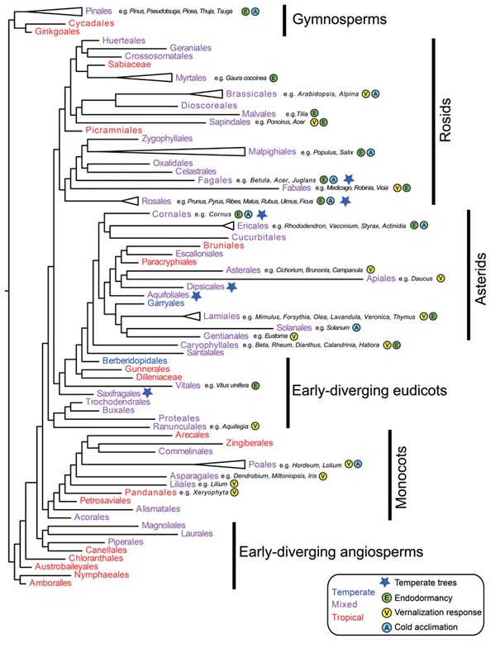

Figure 3 – Phylogenetic tree of different seed producing plant families, taken and adapted from (Preston & Sandve 2013). Individual members of represented families examined in this review have been indicated with a grey box around the family name and attributes. Approximate ages of families taken from (Stevens 2001)

|  |  |  |
| --- | --- | --- |
| **Family** | **Age (million years old)** | **Location** |
| Asterales |  | http://www.mobot.org/MOBOT/research/APweb/orders/ asteralesweb.htm#Asterales |
| Brassicales |  | http://www.mobot.org/MOBOT/research/APweb/orders/ brassicalesweb.htm#Brassicales |
| Caryophyllales |  | http://www.mobot.org/MOBOT/research/APweb/orders/ caryophyllalesweb.htm#Caryophyllales |
| Fabales |  | http://www.mobot.org/MOBOT/research/APweb/orders/ fabalesweb.htm#Fabales |
| Gentianales |  | http://www.mobot.org/MOBOT/research/APweb/orders/ gentianalesweb.htm#Gentianales |
| Poales |  | http://www.mobot.org/MOBOT/research/APweb/orders/ poalesweb.htm#Poales |

Table 1 – Approximate ages of investigated families. (Stevens 2001). Approximate age of family has been derived from the references in the age section of site where possible.

Conclusions

In numerous plant species, the presence/absence of a vernalisation response has been documented for quite some time. While the phenotypic response to vernalisation is consistent between different facultative or absolute vernalisation species, the underlying genetic mechanisms that underpin these responses differ substantially. During vernalisation in *Arabidopsis*, *FLC* expression is repressed via epigenetic modification of the *FLC* locus. Histone methylation and the associated condensing of the chromatin surrounding *FLC*, blocks transcriptional machinery access to the locus, and thus repressing FLC expression and subsequent promotion of the expression of *FT* and other genes downstream of FLC in the *Arabidopsis* flowering pathway. In barely however, repression of VRN2 by VRN1 promotes the expression of the FT homolog, VRN3, allowing the transition of barley to flowering. Sugar beet has a different mechanism again, encoding two FT homologs, *Bv*FT1 and *Bv*FT2, with opposing functiuonal roles in the sugar beet flowering pathway. It has also been shown that while both *Eustoma* and *Arabidopsis* express FLC homologs, EgFLCL has the opposite effect on EgFTL expression in *Eustoma* than the repressive nature of AtFLC on AtFT expression in Arabidopsis. Together, this data begs the question: is the role of FT expression repression by FLC unique to members of the *Brassicaceae* family members?

In the plant varieties discussed above that are vernalisation responsive, *FT* (or its variants), is expressed in true leaves, with the downstream targets of FT expressed in the shoot apical meristem. While the downstream effects of extended cold exposure can be observed in the phenotypic vernalisation response, the molecular mechanisms of how plants detect cold in the first instance is still poorly understood, and difficult to elucidate. It was hoped that with the rapid expansion of gene expression analysis via NGS, the molecular basis of such mechanisms would be uncovered, at least partially. However, to date, this has not proven to be the case. While NGS technology has provided amazing insight into many fundamental questions, such an approach has failed to shed any additional light on the molecular mechanisms that plants use to detect exposure to cold. Perhaps there is another factor involved. In all of the examples of vernalisation examined, and while the gene affected by vernalisation has been repeatedly demonstrated, the specific mechanism that causes this effect remains to be identified in each instance. Helliwell and colleagues (2015) postulated that physical changes brought on by vernalisation conditions modulates the way DNA behaves in cells, essentially removing the natural elasticity of the DNA. Therefore, if a locus adopts an open confirmation during the cold, it will remain open, allowing prolonged access to the site for the associatedgenetic machinery. This may be another avenue of investigation to characterise the physical modifications, at the molecular level, that vernalisation has on all vernalisation responsive plants, not just *Arabidopsis*.

**References**

For submission to trends in Plant Science – NB: Mendeley referencing style for submission is IEEE

Abou-Elwafa, S.F. et al., 2011. Conservation and divergence of autonomous pathway genes in the flowering regulatory network of Beta vulgaris. *Journal of Experimental Botany*, 62(10), pp.3359–3374. Available at: http://jxb.oxfordjournals.org/content/62/10/3359.abstract.

Airoldi, C.A., McKay, M. & Davies, B., 2015. MAF2 Is Regulated by Temperature-Dependent Splicing and Represses Flowering at Low Temperatures in Parallel with FLM. *PLoS ONE*, 10(5), p.e0126516. Available at: http://dx.doi.org/10.1371%2Fjournal.pone.0126516.

Alessandro, M. et al., 2013. Molecular mapping of vernalization requirement and fertility restoration genes in carrot. *Theoretical and Applied Genetics*, 126(2), pp.415–423. Available at: http://dx.doi.org/10.1007/s00122-012-1989-1.

Amasino, R., 2004. Vernalization, Competence, and the Epigenetic Memory of Winter. *The Plant Cell Online*, 16(10), pp.2553–2559. Available at: http://www.plantcell.org/content/16/10/2553.short.

Angus, J.F. et al., 1980. Phasic development in field crops. I. Thermal response in the seedling phase. *Field Crop Research*, 3, pp.365–378.

Bastow, R. et al., 2004. Vernalization requires epigenetic silencing of FLC by histone methylation. *Nature*, 427(6970), pp.164–167. Available at: http://dx.doi.org/10.1038/nature02269.

Burn, J.E. et al., 1993. DNA methylation, vernalization, and the initiation of flowering. *Proceedings of the National Academy of Sciences*, 90(1), pp.287–291. Available at: http://www.pnas.org/content/90/1/287.abstract.

Chao, Y. et al., 2013. Expression of the alfalfa FRIGIDA-Like Gene, MsFRI-L delays flowering time in transgenic Arabidopsis thaliana. *Molecular Biology Reports*, 40(3), pp.2083–2090. Available at: http://dx.doi.org/10.1007/s11033-012-2266-8.

Chia, T.Y.P. et al., 2008. Sugar beet contains a large CONSTANS-LIKE gene family including a CO homologue that is independent of the early-bolting (B) gene locus. *Journal of Experimental Botany*, 59(10), pp.2735–2748. Available at: http://jxb.oxfordjournals.org/content/59/10/2735.abstract.

Corbesier, L. et al., 2007. FT Protein Movement Contributes to Long-Distance Signaling in Floral Induction of Arabidopsis. *Science*, 316(5827), pp.1030–1033. Available at: http://www.sciencemag.org/content/316/5827/1030.abstract.

Dijk, H. Van et al., 1997. Flowering time in wild beet (Beta vulgaris ssp. maritima) along a latitudinal cline. *Acta Oecologica*, 18(1), pp.47–60. Available at: http://www.sciencedirect.com/science/article/pii/S1146609X9780080X.

Etter, A.G., 1951. How Kentucky Bluegrass Grows. *Annals of the Missouri Botanical Garden*, 38(3), pp.293–375 CR – Copyright &#169; 1951 Missouri Botani. Available at: http://www.jstor.org/stable/2394639.

Finnegan, E.J. et al., 2005. The downregulation of FLOWERING LOCUS C (FLC) expression in plants with low levels of DNA methylation and by vernalization occurs by distinct mechanisms. *The Plant Journal*, 44(3), pp.420–432. Available at: http://dx.doi.org/10.1111/j.1365-313X.2005.02541.x.

Finnegan, E.J. & Dennis, E.S., 2007. Vernalization-Induced Trimethylation of Histone H3 Lysine 27 at FLC Is Not Maintained in Mitotically Quiescent Cells. *Current Biology*, 17(22), pp.1978–1983. Available at: http://www.cell.com/current-biology/abstract/S0960-9822(07)02087-8.

Fletcher, J.C., 2002. Shoot and Floral Meristem Maintenance in Arabidopsis. *Annual Review of Plant Biology*, 53(1), pp.45–66. Available at: http://dx.doi.org/10.1146/annurev.arplant.53.092701.143332.

Gassner, G., 1918. Beiträge zur physiologiischen Charakteristik sommer- und winterannueller Gewächse, insbesondere der Getreidepflanzen. *Zeitschrift für Botanik*, 10, pp.417–480.

Gladstones, J.S. & Hill, G.D., 1969. Selection for economic characters in Lupinus angustifolius and L. digitatus. 2. Time of flowering. *Australian Journal of Experimental Agriculture*, 9(37), pp.213–220. Available at: http://www.publish.csiro.au/paper/EA9690213.

Gray, S.G., 1942. Increased Earlieness of Flowering in Lettuce Through Vernalisation. *Journal of the Council for Scientific and Industrial Research, Australia*, 15(3), pp.211–212.

Greenup, A.G. et al., 2010. ODDSOC2 Is a MADS Box Floral Repressor That Is Down-Regulated by Vernalization in Temperate Cereals. *Plant Physiology*, 153(3), pp.1062–1073. Available at: http://www.plantphysiol.org/content/153/3/1062.abstract.

Hecht, V. et al., 2005. Conservation of Arabidopsis Flowering Genes in Model Legumes. *Plant Physiology*, 137(4), pp.1420–1434. Available at: http://www.scopus.com/inward/record.url?eid=2-s2.0-84892462923&partnerID=tZOtx3y1.

Hecht, V. et al., 2011. The Pea GIGAS Gene Is a FLOWERING LOCUS T Homolog Necessary for Graft-Transmissible Specification of Flowering but Not for Responsiveness to Photoperiod. *The Plant Cell Online*, 23(1), pp.147–161. Available at: http://www.plantcell.org/content/23/1/147.abstract.

Helliwell, C.A. et al., 2015. How is FLC repression initiated by cold? *Trends in Plant Science*, 20(2), pp.76–82. Available at: http://dx.doi.org/10.1016/j.tplants.2014.12.004.

Ivany, L.C., Patterson, W.P. & Lohmann, K.C., 2000. Cooler winters as a possible cause of mass extinctions at the Eocene/Oligocene boundary. *Nature*, 407(6806), pp.887–890. Available at: http://dx.doi.org/10.1038/35038044.

Jaudal, M. et al., 2013. Retroelement insertions at the Medicago FTa1 locus in spring mutants eliminate vernalisation but not long-day requirements for early flowering. *The Plant Journal*, 76(4), pp.580–591. Available at: http://dx.doi.org/10.1111/tpj.12315.

Klippart, J.H., 1857. An essay on the origin, growth, diseases, varieties etc of the wheat plant. *Annual Report of the Ohio State Board of Agriculture*, pp.562–720.

Köhler, C. & Villar, C.B.R., 2008. Programming of gene expression by Polycomb group proteins. *Trends in Cell Biology*, 18(5), pp.236–243. Available at: http://www.sciencedirect.com/science/article/pii/S0962892408000809.

Landers, K.F., 1995. Vernalization responses in narrow-leafed lupin (Lupinus angustifolius) genotypes. *Australian Journal of Agricultural Research*, 46(5), pp.1011–1025. Available at: http://www.publish.csiro.au/paper/AR9951011.

Laurie, R.E. et al., 2011. The Medicago FLOWERING LOCUS T Homolog, MtFTa1, Is a Key Regulator of Flowering Time1[C][W][OA]. *Plant Physiology*, 156(4), pp.2207–2224. Available at: http://search.proquest.com/docview/883393205?accountid=26957.

Levy, Y.Y. et al., 2002. Multiple Roles of Arabidopsis VRN1 in Vernalization and Flowering Time Control. *Science*, 297(5579), pp.243–246. Available at: http://www.sciencemag.org/content/297/5579/243.abstract.

De Lucia, F. et al., 2008. A PHD-Polycomb Repressive Complex 2 triggers the epigenetic silencing of FLC during vernalization. *Proceedings of the National Academy of Sciences*, 105(44), pp.16831–16836. Available at: http://www.pnas.org/content/105/44/16831.abstract.

Meyerowitz, E.M., 1997. Genetic Control of Cell Division Patterns in Developing Plants. *Cell*, 88(3), pp.299–308. Available at: http://www.sciencedirect.com/science/article/pii/S0092867400818681.

Nakano, Y. et al., 2011. Characterization of FLC, SOC1 and FT homologs in Eustoma grandiflorum: effects of vernalization and post-vernalization conditions on flowering and gene expression. *Physiologia Plantarum*, 141(4), pp.383–393. Available at: http://dx.doi.org/10.1111/j.1399-3054.2011.01447.x.

Oliver, S.N. et al., 2009. Vernalization-induced flowering in cereals is associated with changes in histone methylation at the VERNALIZATION1 gene. *Proceedings of the National Academy of Sciences*, 106(20), pp.8386–8391. Available at: http://www.pnas.org/content/106/20/8386.abstract.

Owen, F. V., Carsner, E. & Stout, M., 1940. Photothermal induction of flowering in suagr beets. *Journal of Agricultural Research*, 61, pp.101–124.

Pergola, G., 1992. The need for vernalization in Eustoma russellianum. *Scientia Horticulturae*, 51(1–2), pp.123–127. Available at: http://www.sciencedirect.com/science/article/pii/030442389290110X.

Périlleux, C. et al., 2013. A root chicory MADS box sequence and the Arabidopsis flowering repressor FLC share common features that suggest conserved function in vernalization and de-vernalization responses. *The Plant Journal*, 75(3), pp.390–402. Available at: http://dx.doi.org/10.1111/tpj.12208.

Pin, P.A. et al., 2010. An Antagonistic Pair of FT Homologs Mediates the Control of Flowering Time in Sugar Beet. *Science*, 330(6009), pp.1397–1400. Available at: http://www.sciencemag.org/content/330/6009/1397.abstract.

Pin, P.A. et al., 2012. The Role of a Pseudo-Response Regulator Gene in Life Cycle Adaptation and Domestication of Beet. *Current Biology*, 22(12), pp.1095–1101. Available at: http://www.cell.com/current-biology/abstract/S0960-9822(12)00394-6.

Preston, J.C. & Sandve, S.R., 2013. Adaptation to seasonality and the winter freeze. *Frontiers in plant science*, 4(JUN), p.167. Available at: http://www.scopus.com/inward/record.url?eid=2-s2.0-84892462923&partnerID=tZOtx3y1 [Accessed March 2, 2015].

Putterill, J. et al., 2013. FT genes and regulation of flowering in the legume Medicago truncatula. *Functional Plant Biology*, 40(12), pp.1199–1207. Available at: http://dx.doi.org/10.1071/FP13087.

Rappapport, L., Wittwer, S.H. & Tukey, H.B., 1956. Seed Vernalization and Flowering in Lettuce (Lactuca sativa). *Nature*, 178(4523), p.51. Available at: http://dx.doi.org/10.1038/178051a0.

Ratcliffe, O.J. et al., 2003. Analysis of the Arabidopsis MADS AFFECTING FLOWERING Gene Family: MAF2 Prevents Vernalization by Short Periods of Cold. *The Plant Cell Online*, 15(5), pp.1159–1169. Available at: http://www.plantcell.org/content/15/5/1159.abstract.

Ream, T.S. et al., 2014. Interaction of Photoperiod and Vernalization Determines Flowering Time of Brachypodium distachyon. *Plant Physiology*, 164(2), pp.694–709. Available at: http://www.plantphysiol.org/content/164/2/694.abstract.

Reeves, P.A. et al., 2007. Evolutionary Conservation of the FLOWERING LOCUS C-Mediated Vernalization Response: Evidence From the Sugar Beet (Beta vulgaris). *Genetics*, 176(1), pp.295–307. Available at: http://www.ncbi.nlm.nih.gov/pmc/articles/PMC1893026/.

Reid, J.B. & Murfet, I.C., 1975. Flowering in Pisum: the Sites and Possible Mechanisms of the Vernalization Response. *Journal of Experimental Botany*, 26(6), pp.860–867. Available at: http://jxb.oxfordjournals.org/content/26/6/860.abstract.

Riechmann, J.L. & Meyerowitz, E.M., 1997. MADS domain proteins in plant development. *Biological Chemistry*, 378, pp.1079–1118. Available at: //www.degruyter.com/view/j/bchm.1997.378.issue-10/bchm.1997.378.10.1079/bchm.1997.378.10.1079.xml.

Sheldon, C.C. et al., 2000. The molecular basis of vernalization: The central role of FLOWERING LOCUS C (FLC). *Proceedings of the National Academy of Sciences*, 97(7), pp.3753–3758. Available at: http://www.pnas.org/content/97/7/3753.abstract.

Silva, I.P. & Jenkins, D.G., 1993. Decision on the Eocene-Oligocene boundary stratotype. *Episodes*, 16(3), pp.379–382.

Speelman, E.N. et al., 2009. The Eocene Arctic Azolla bloom: environmental conditions, productivity and carbon drawdown. *Geobiology*, 7(2), pp.155–170. Available at: http://dx.doi.org/10.1111/j.1472-4669.2009.00195.x.

Stevens, P.F., 2001. Angiopserm Phylogeny Website (v13). Available at: http://www.mobot.org/MOBOT/research/APweb/.

Sung, S. & Amasino, R.M., 2004. Vernalization and epigenetics: how plants remember winter. *Current Opinion in Plant Biology*, 7(1), pp.4–10. Available at: http://www.sciencedirect.com/science/article/pii/S1369526603001419.

Trevaskis, B. et al., 2006. HvVRN2 Responds to Daylength, whereas HvVRN1 Is Regulated by Vernalization and Developmental Status. *Plant Physiology*, 140(4), pp.1397–1405. Available at: http://www.plantphysiol.org/content/140/4/1397.abstract.

Trevaskis, B. et al., 2003. MADS box genes control vernalization-induced flowering in cereals. *Proceedings of the National Academy of Sciences*, 100(22), pp.13099–13104. Available at: http://www.pnas.org/content/100/22/13099.abstract.

Trevaskis, B., Tadege, M., et al., 2007. Short Vegetative Phase-Like MADS-Box Genes Inhibit Floral Meristem Identity in Barley. *Plant Physiology*, 143(1), pp.225–235. Available at: http://www.ncbi.nlm.nih.gov/pmc/articles/PMC1761976/.

Trevaskis, B., Hemming, M.N., et al., 2007. The molecular basis of vernalization-induced flowering in cereals. *Trends in Plant Science*, 12(8), pp.352–357. Available at: http://www.sciencedirect.com/science/article/pii/S1360138507001562.

Wang, X., 2010. *The Dawn Angiosperms*, Berlin: Berlin. Available at: http://www.mobot.org/MOBOT/research/APweb/.

Warne, L.G.G., 1947. Vernalization of Lettuce. *Nature*, 159(4027), pp.31–32.

Waycott, W., 1995. Photoperiodic Response of Genetically Diverse Lettuce Accessions. *Journal of the American Society for Horticultural Science*, 120(3), pp.460–467. Available at: http://journal.ashspublications.org/content/120/3/460.abstract.

Wellensiek, S.J., 1962. Dividing Cells as the Locus for Vernalization. *Nature*, 195(4838), pp.307–308. Available at: http://dx.doi.org/10.1038/195307a0.

Werner, J.D. et al., 2005. FRIGIDA-independent variation in flowering time of natural Arabidopsis thaliana accessions. *Genetics*, 170(3), pp.1197–1207.

Wetterstrand, K., 2014. DNA Sequencing Costs: Data from the NHGRI Genome Sequencing Program (GSP). Available at: http://www.genome.gov/sequencingcosts/ [Accessed December 27, 2014].

Yan, L. et al., 2004. The Wheat VRN2 Gene Is a Flowering Repressor Down-Regulated by Vernalization. *Science*, 303(5664), pp.1640–1644. Available at: http://www.sciencemag.org/content/303/5664/1640.abstract.

Zimmerman, L.H., 1973. Effect of Photoperiod and Temperature On Rosette Habit in Safflower. , pp.80–81. Available at: https://dl.sciencesocieties.org/publications/cs/abstracts/13/1/80.